@porrtal Features

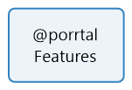

**No table of contents entries found.**